

Beauty of beaches
STUDENTS | - HARIS(1728428)  - BILAL(1728725)  - BASIT (1730684)
FACULTY | Muneeb Farhan
BATCH | 26-05B
SEMESTER | 1ST Semester

Index

Introduction 3
Objectives of Projects 4
Problem Statement 5
Home Page 6
Beaches Page 7
Gallery Page 8
Travel Page 9
About Page 10
Contact Us Page 11
Queries Page 12
Site Map Page 13

Introduction

The thirst for learning, upgrading technical skills and applying the concepts in real life environment at a fast pace is what the industry demands from IT professionals today. However busy work schedules, far-flung locations, unavailability of convenient time-slots pose as major barriers when it comes to applying the concepts into realism. And hence the need to look out for alternative means of implementation in the form of laddered approach.

The above truly pose as constraints especially for our students too! With their busy schedules, it is indeed difficult for our students to keep up with the genuine and constant need for integrated application which can be seen live especially so in the field of IT education where technology can change on the spur of a moment. Well, technology does come to our rescue at such times!!

Keeping the above in mind and in tune with our constant endeavour to use Technology in our training model, we at Aptech have thought of revolutionizing the way our students learn and implement the concepts using tools themselves by providing a live and synchronous eProject learning environment!

So what is this eProject?

eProject is a step-by-step learning environment that closely simulates the classroom and Lab based learning environment into actual implementation. It is a project implementation at your fingertips!! An electronic, live juncture on the machine that allows you to

- Practice step by step i.e. laddered approach.
- Build a larger more robust application.
- Usage of certain utilities in applications designed by user.
- Single program to unified code leading to a complete application.
- Learn implementation of concepts in a phased manner.
- Enhance skills and add value.
- Work on real life projects.
- Give a real life scenario and help to create applications more complicated and useful.
- Mentoring through email support.

The students at the centre are expected to complete this eProject and send complete project along with the documentation to eProjects Team

Looking forward to a positive response from your end!!

Objectives of Projects

The Objective of this program is to give a sample project to work on real life projects. These applications help you build a larger more robust application.

The objective is not to teach you JSON/JavaScript/Dreamweaver/HTML5 but to provide you with a real life scenario and help you create basic applications using the tools.

You can revise the chapters before you start with the project.

This project is meant for students who have completed the module of HTML5. These programs should be done in the Lab sessions with assistance of the faculty if required.

It is very essential that a student has a clear understanding of the subject. Students should go through the project and solve the assignments as per requirements given.

Kindly get back to eProjects Team in case of any doubts regarding the application or its objectives.
.

Problem Statement

The most important economic benefit of beaches is that they serve as a tourist attraction site. Tourism is the largest economic activity in the world and it not only earns countries foreign revenue, but also acts as a large employer for the local population. “BeautyOfBeaches” will be the website that will provide the information about famous beaches in the world. The information can be categorized based on zone wise (NORTH, SOUTH, WEST and EAST).

You are supposed to create a Single-Page-Application and responsive Website for them with the below mentioned requirement specifications.

The website should work well in all leading browsers including Chrome, IE, Firefox etc.

Functional Requirement Specification:

The portal will be designed as a Single-Page-Application and responsive Website with a set of pages and menus that represent choice of activities to be performed. The pages, menus, and other visual elements must be designed in a visually appealing manner with attractive fonts, colors, and animations.

All of these should also be laid out in a responsive manner

The Web site is to be created based on the following requirements.

- The Top of the Page should be presented with a suitable logo and various famous images of respective beaches.
- The site must contain the links to navigate through any zone for the information.
- Links of beaches can be categorized by zone wise like (East, North, West and South)
- Gallery can be added for viewing different images.
- Feedback must be allowed to enter by the viewer
- Site map, Gallery, about us, Queries link, Contact us link must be added.
- About Us and Contact Us: This menu option should display Email id, address, and contact number of the organization who is developing the system.

Home Page

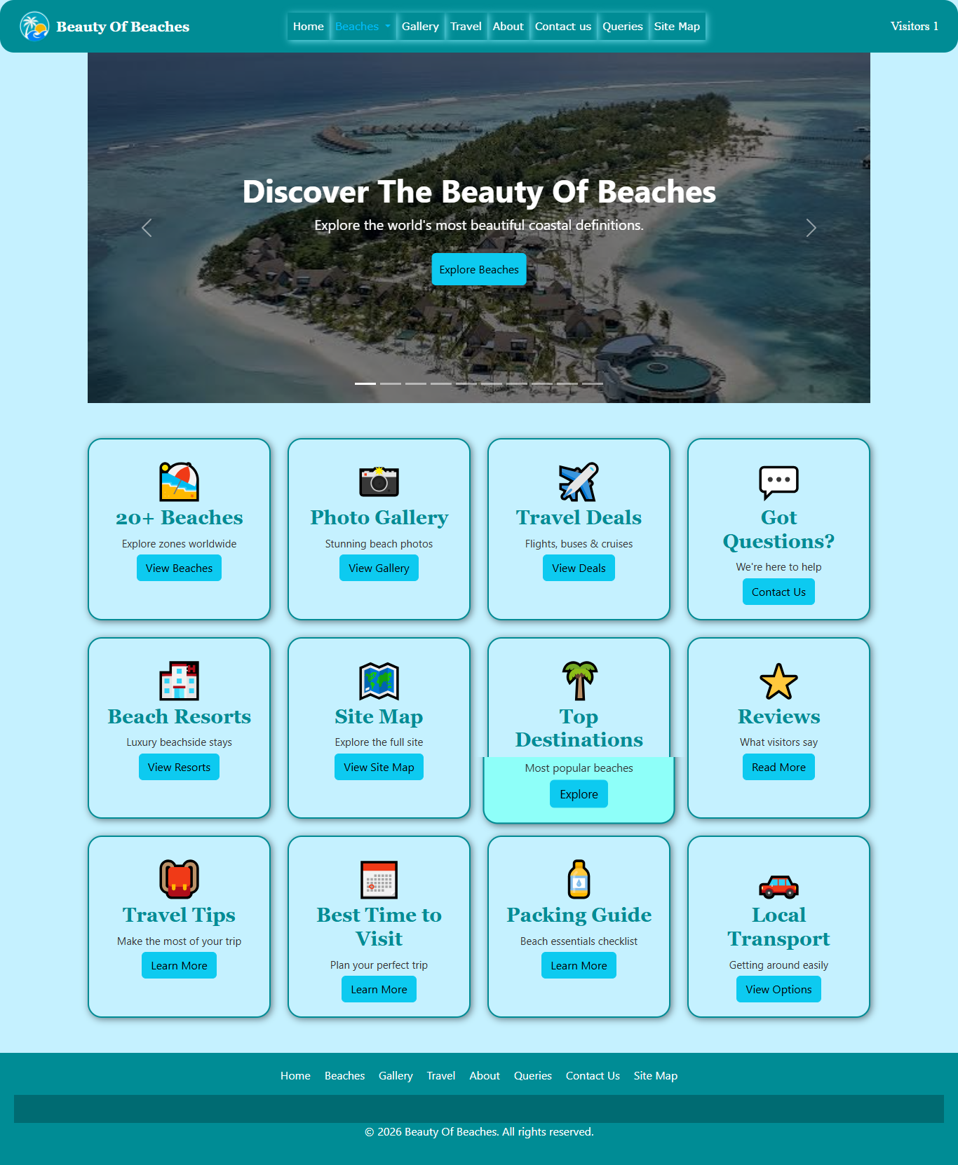

Beaches Page

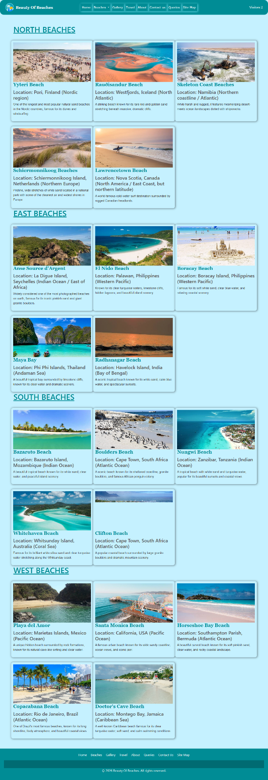

Gallery Page
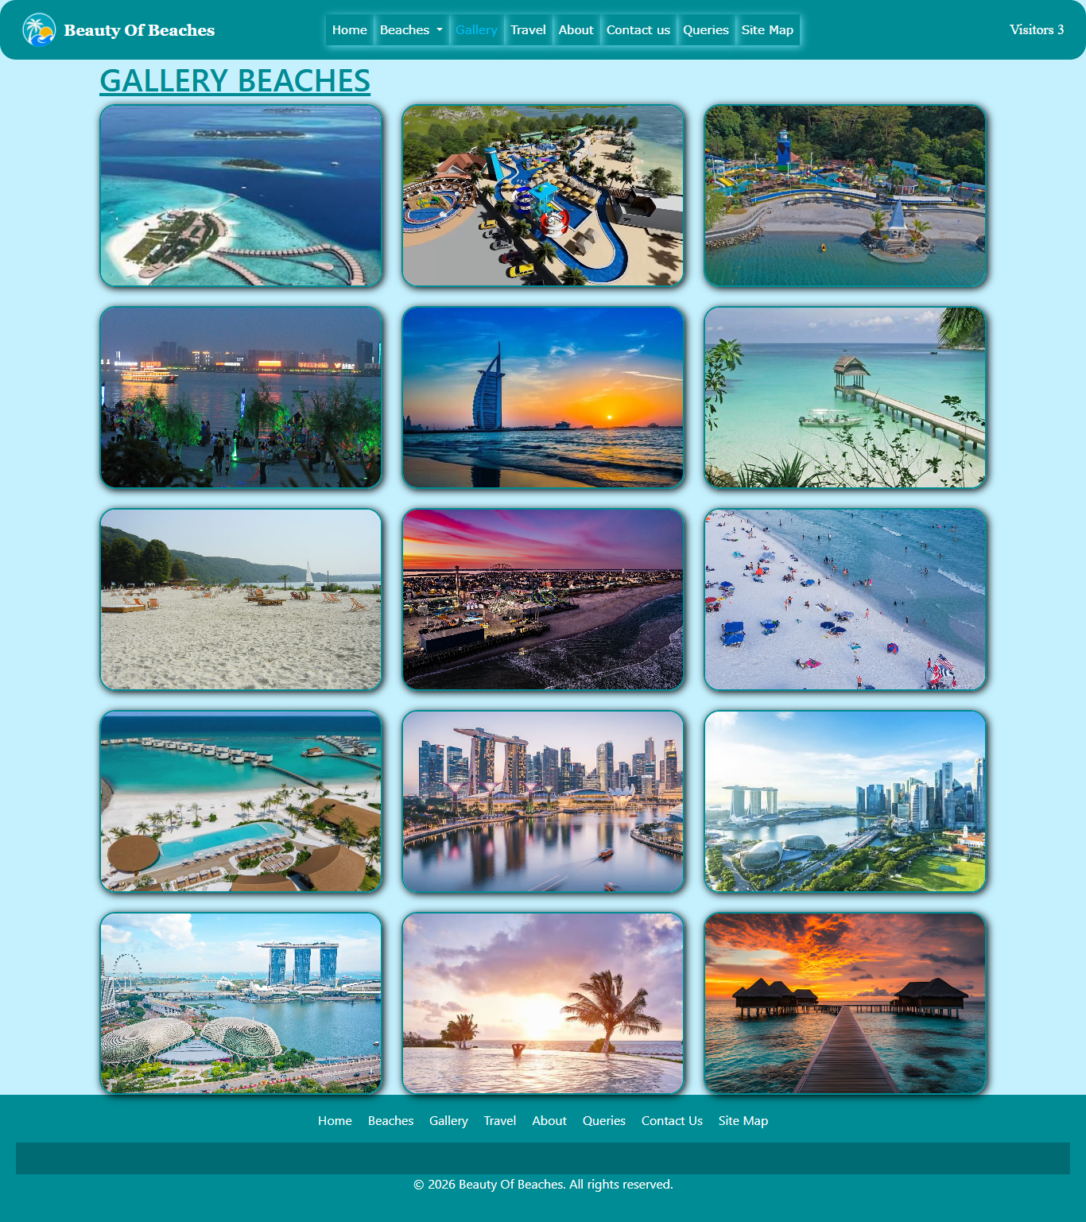

Travel Page

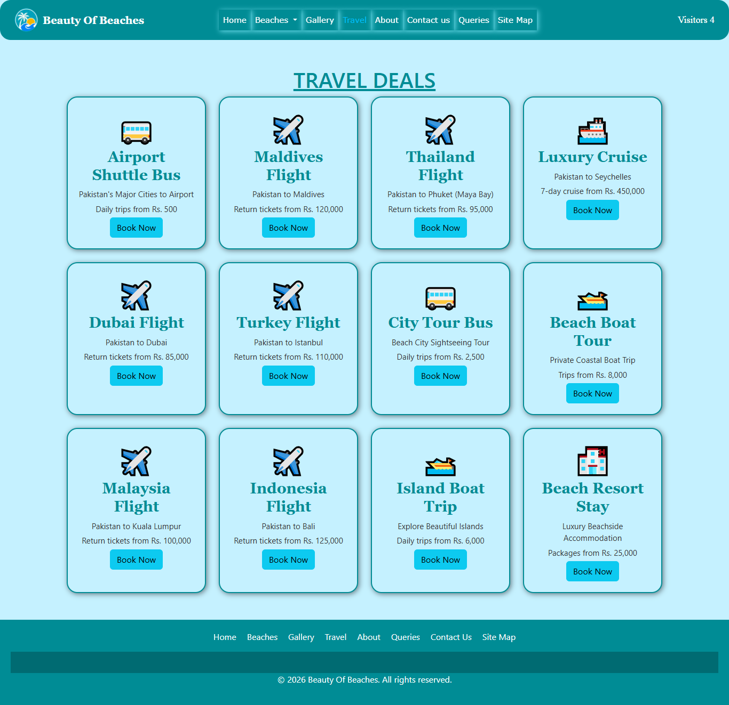

About Page

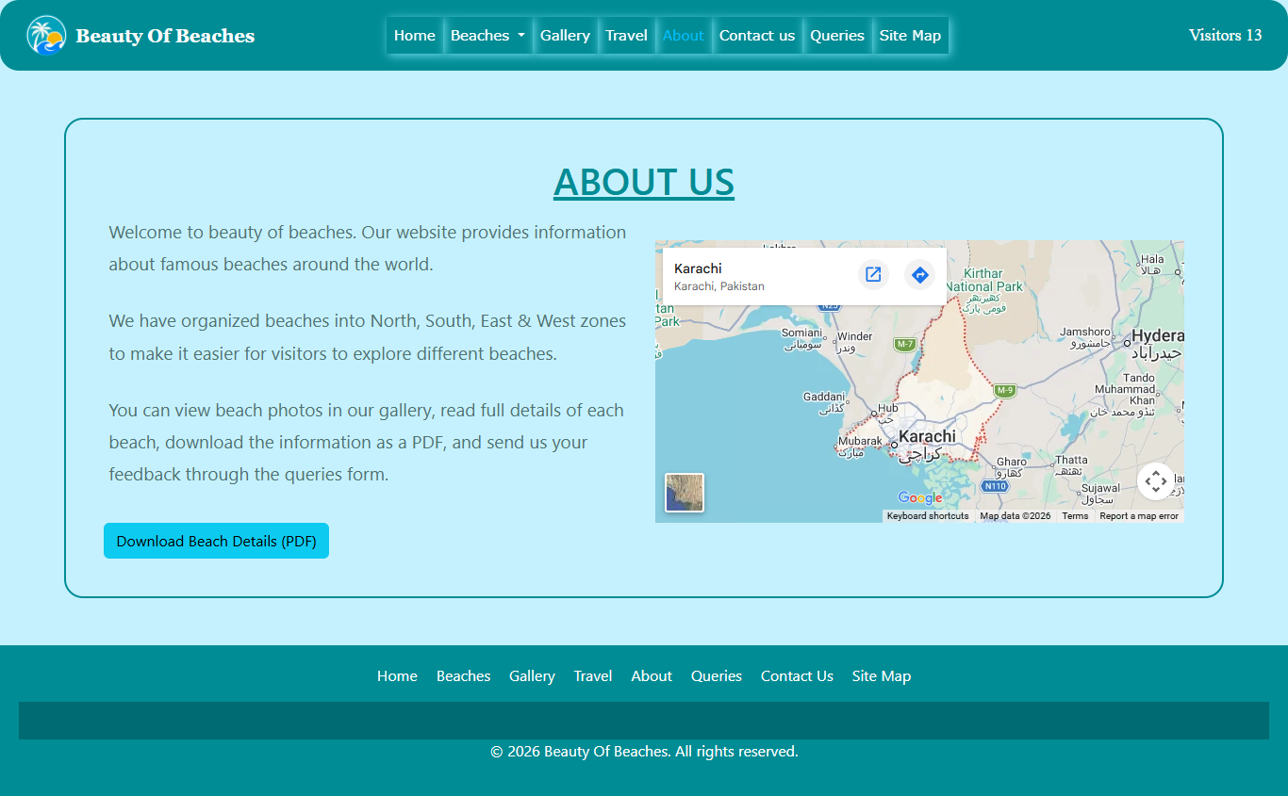

Contact us Page

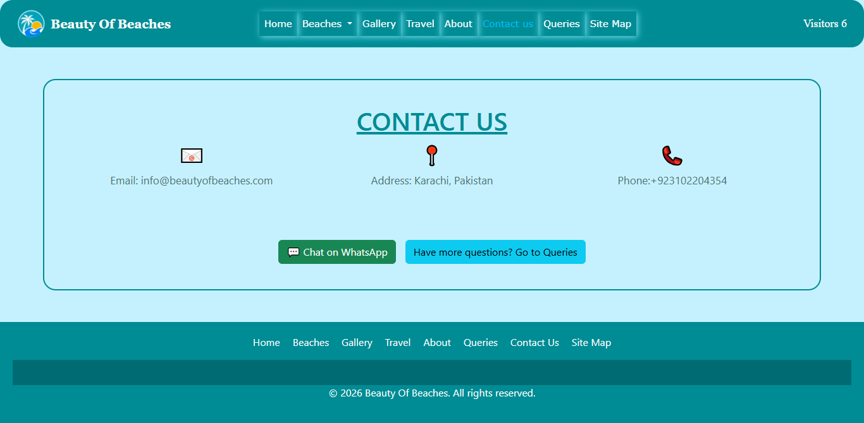

Queries Page
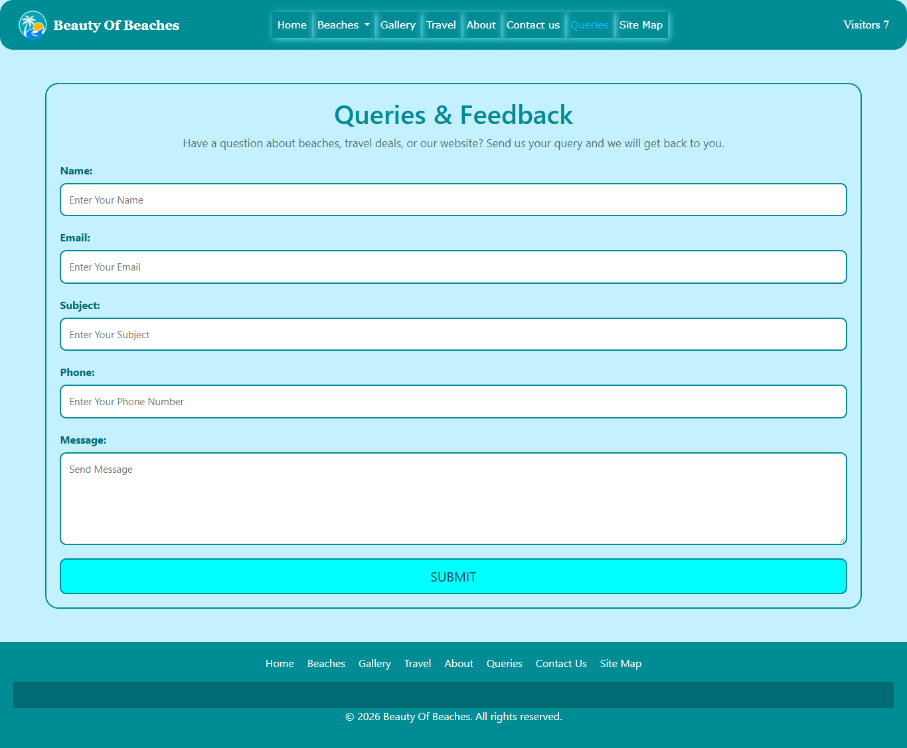

Sitemap Page
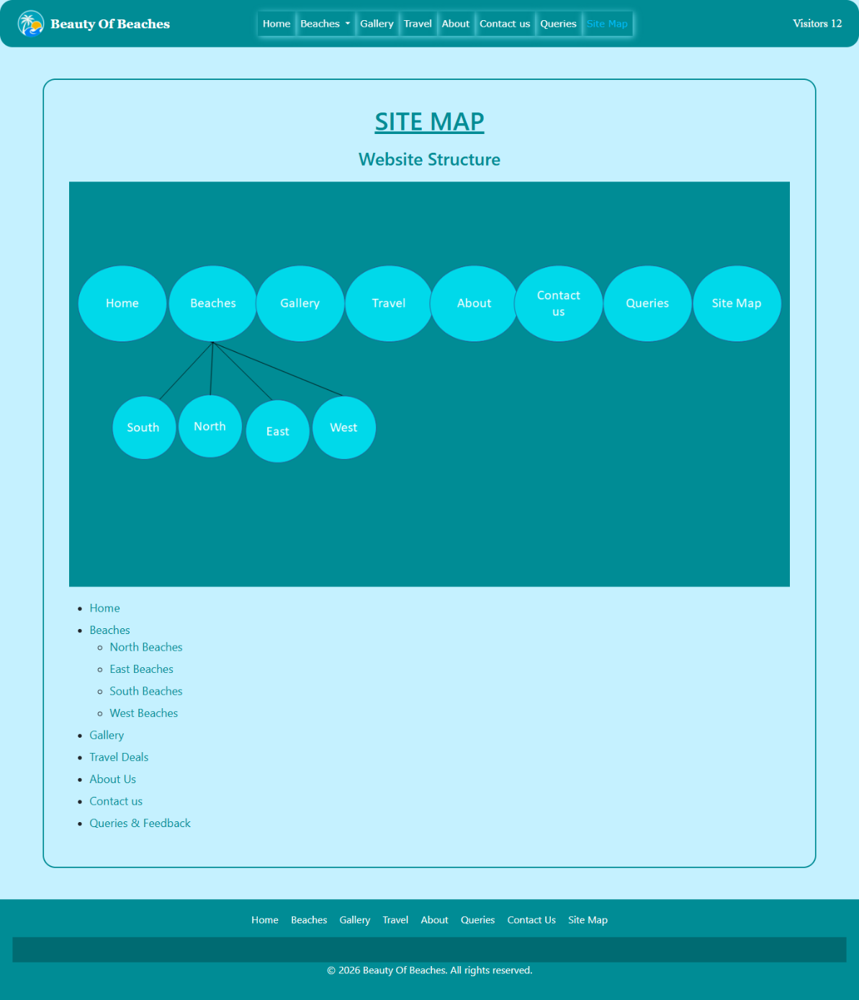

Thank You.

